
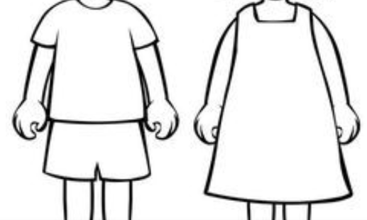
Name ________________
Indeed, the very hairs of your head are all numbered. Don’t be afraid; you are worth more than many sparrows.

Luke 12:7

